Practical No. 1
- Team Setup: Form teams and assign roles (e.g., developer, tester, operations).
- Git Installation: Download and Install git on your machine.

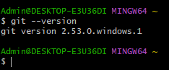

- Configuration: Configure Git using your mail account and then verify it.
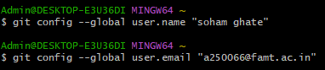

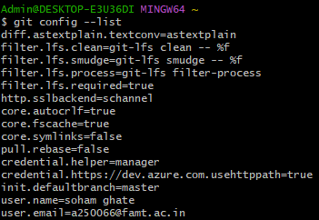

- Initialization: Initialize or create a new Git repository and verify it.
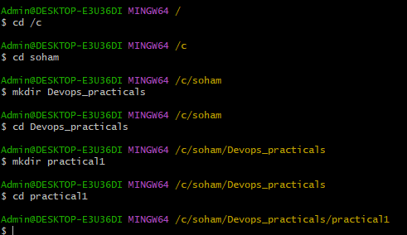

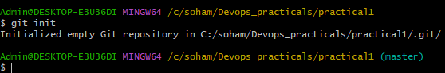
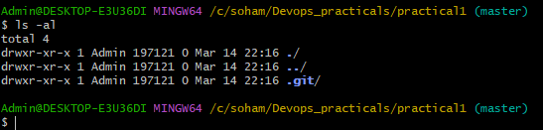
5. Git Hub account: Sign in to www.github. com for an online repository which is available at
anytime and anywhere.
